- OWN HOROSCOPE ANALYSIS
2,6,11
5,8,12

- PRASANNAM
  - RAGHU
  - KETHU

- THITHI
- KARANAM
- YOGAM
- NATCHATHIRAM

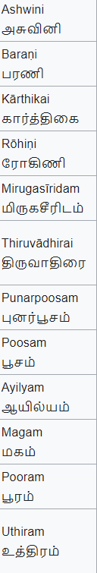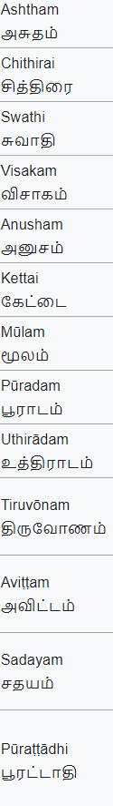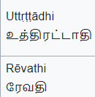

NATCHATHIRA
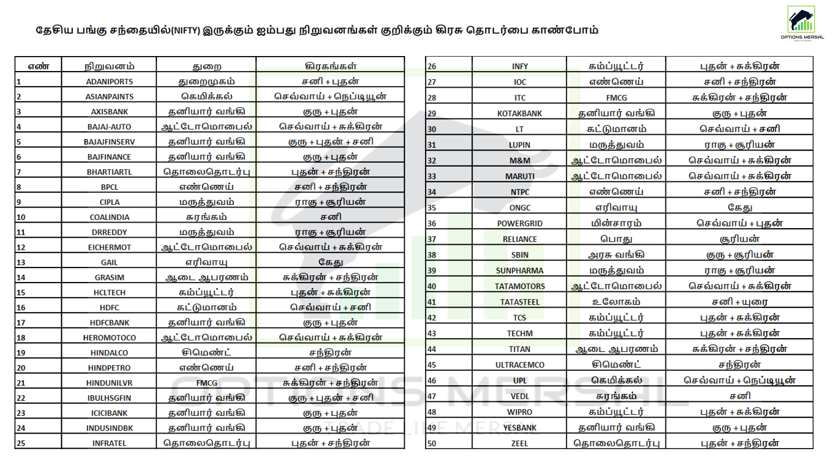

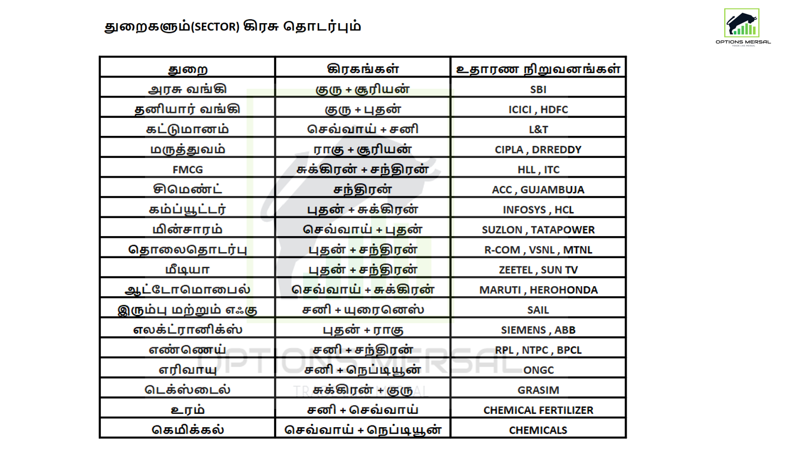
THITHI
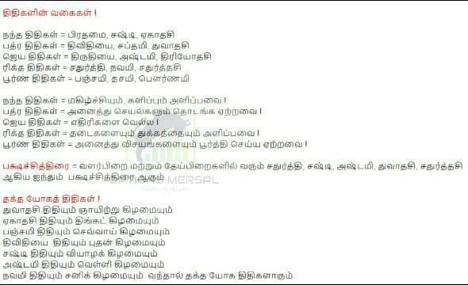

YOGAM
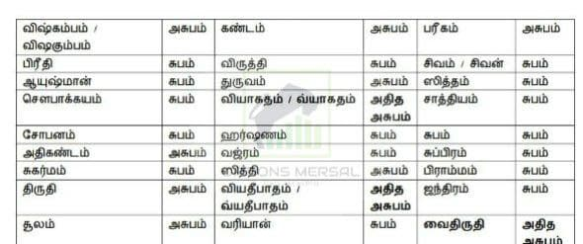

KARANAM
